TASK 1:

Create a public repo HAZESOFT-T1 in your github account.

Create a Dockerfile which can automate the following tasks:

Use the alpine linux image

Setup nginx server

Clone the given repo https://github.com/veekrum/task

Copy site folder from the cloned repo to the nginx document root folder

Expose the port 9000 in the host and link with the default nginx port

Push your Dockerfile to the repo.

OUTPUT:

When the docker is run,the html file should be accessible from the browser at <http://localhost:9000/site/index.html>

………………………………………………………………………………………………………………..

- Created a repo named as "HAZESOFT-T1" in git account.

- Install the Docker in your system using the following command.

sudo apt-get install docker-ce docker-ce-cli containerd.io docker-buildx-plugin docker-compose-plugin

- Check the status whether Docker is enable or not using the following command

sudo systemctl status docker.

* If running u will get this..
* 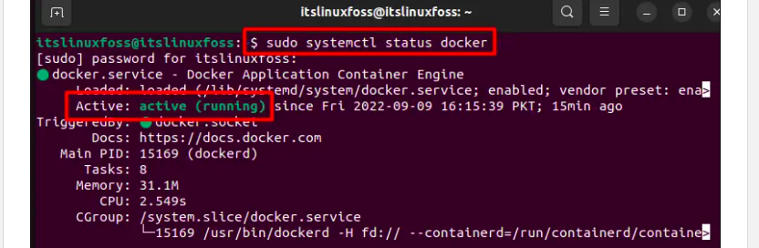
* - Create the Dockerfile inside the "hazesoft" directory using the following command.
* mkdir hazesoft
* cd hazesoft
* nano Dockerfile
* - Then write the command.
* FROM alpine:latest
* RUN apk update && apk add nginx
* RUN apk add git && git clone https://github.com/veekrum/task /tmp/task
* RUN cp -r /tmp/task/site /usr/share/nginx/html
* COPY ./hazesoftassignment.conf /etc/nginx/http.d/default.conf
* EXPOSE 9000
* CMD ["nginx", "-g", "daemon off;"]
* Also i have made the hazesoftassignment.conf file and inserted the following command and saved it..
* server {
* listen 80;
* server_name localhost;
* location / {
* root /usr/share/nginx/html;
* index index.html;
* }
* location /site/ {
* alias /usr/share/nginx/html/site/;
* index index.html;
* }
* }
* - Now build and run by using the following command in the terminal.
* sudo docker build -t hazesoft-t1 .
* sudo docker run -p 9000:80 hazesoft-t1
* Here, -t means tagname i.e hazesoft and "." represent the file is in current directory.
* -p 9000:80: Maps port 9000 on the host to port 80 on the container. This allows you to access the web server running inside the container at http://localhost:9000/site/index.html
* 